CSA6303 - THREAT INTELLIGENCE AND NETWORK SECUR
Assessment Tool 1: CONCEPT MAPPING
Faculty : Dr.V.Parthipan SLOT A

Topics: Network Security Fundamentals | Security Goals (CIA Triad) | Types of Network Threats |Introduction to Threat Intelligence Types of Threat Intelligence (Strategic, Tactical, perational) — Threat Intelligence Lifecycle — Applications in IT Industry
CO1: Interpret security principles, network threats, and the role of threat intelligence in cybersecurity.

Total: 50
Student Name : G.B.Hari Haran Register number: 192412390

Code of Conduct:

I G.B.Hari Haran / 192412390 certify that this submission is my original work and that I have adhered to the guidelines specified for this assessment. I understand that any violation of academic integrity rules will result in disciplinary action.
G.B.Hari Haran
Signature of the student

CO1 – Concept Mapping Questions
No. | Concept-Mapping Question
1 | Construct a comprehensive concept map explaining the foundations of Network Security. Connect network security fundamentals with security objectives, the CIA Triad (Confidentiality, Integrity, and Availability), network assets, vulnerabilities, threats, and protective measures, and explain how these concepts collectively support secure network operations.
2 | Develop a concept map illustrating the CIA Triad as the foundation of network security. Relate Confidentiality, Integrity, and Availability to different types of network threats and demonstrate how a single threat can affect one or more security goals.
3 | Construct a concept map classifying different types of Network Threats and their potential impact on security goals. Connect threats such as malware, phishing, denial-of-service, spoofing, eavesdropping, and unauthorized access with the CIA Triad and explain the resulting security implications.
4 | Develop an integrated concept map connecting Network Security Fundamentals, Network Threats, and Threat Intelligence. Show how identifying assets, vulnerabilities, and threats leads to the collection and analysis of threat information and ultimately supports informed security decisions.
5 | Construct a concept map explaining the concept of Threat Intelligence and its role in modern network security. Relate threat actors, indicators, vulnerabilities, attack patterns, threat information, analysis, and actionable intelligence to demonstrate how Threat Intelligence helps organizations anticipate and respond to network threats.
6 | Develop a comparative concept map of Strategic, Tactical, and Operational Threat Intelligence. Connect each type with its purpose, target audience, time horizon, information requirements, decision-making process, and appropriate network-security use cases, and analyze how the three intelligence types complement one another.
7 | Construct a concept map representing the complete Threat Intelligence Lifecycle. Connect planning/direction, collection, processing, analysis, dissemination, and feedback with the identification of network threats and security requirements, showing how feedback continuously improves the intelligence process.
8 | Develop an end-to-end concept map showing how a network threat progresses from identification to actionable Threat Intelligence. Connect network security fundamentals, CIA security goals, threat detection, intelligence collection, processing, analysis, dissemination, and response, and explain the relationship between each stage.
9 | Create a scenario-based concept map for an organization experiencing a major network attack. Integrate the CIA Triad, types of network threats, Strategic Intelligence, Tactical Intelligence, Operational Intelligence, and the Threat Intelligence Lifecycle to demonstrate how the organization can understand, prioritize, and respond to the threat.
10 | Design a comprehensive concept map demonstrating the applications of Network Security and Threat Intelligence in the IT industry. Connect network security fundamentals, CIA Triad, network threats, Threat Intelligence, Strategic/Tactical/Operational Intelligence, and the Threat Intelligence Lifecycle with applications such as threat monitoring, incident response, vulnerability management, risk assessment, security operations, and organizational decision-making.

Register Number | Name of the Students | CO1 AT1 Questions
192465054 | AJJUGUTTU ABHINAVA REDDY | Q1 & Q2
192365035 | AMMINENI SUCHARITHA | Q3 & Q4
192465061 | ANNAMREDDY BHARGAV REDDY | Q5 & Q6
192465033 | BOMMISETTY VENKATESWARALU | Q7 & Q8
192311098 | BOTCHA HARI SAI | Q9 & Q10
192465058 | DUSYAANT R | Q1 & Q2
192521124 | Davis Damien M | Q3 & Q4
192365038 | EPURU DHARMIK REDDY | Q5 & Q6
192425089 | GUNDA ASWARTHA MANIDHEEP | Q7 & Q8
192412390 | HARIHARAN G B | Q9 & Q10
192311096 | K MUNI KULADEEP | Q1 & Q2
192411156 | KEERTHIPATI HEMA SREE | Q3 & Q4
192465057 | KEVINASHREE V K | Q5 & Q6
192465005 | KHADEER BASHA M | Q7 & Q8
192365025 | KONGARA SAI | Q9 & Q10
192365017 | LINGALA MITHUN KUMAR REDDY | Q1 & Q2
192311133 | MARINENI VARUNKUMAR | Q3 & Q4
192365032 | Mokharala Devi Vara Prasad | Q5 & Q6
192311129 | NARRA HARSHITH | Q7 & Q8
192365053 | NIMMALA CHAWRAN ARYAN | Q9 & Q10
192465051 | P P ANKAIAHGARI LAKSHMI SRINIVASULU REDDY | Q1 & Q2
192365052 | PALURU LIKITH VARDHAN | Q3 & Q4
192311128 | PATAKOTTU VENKATA PRANAVA SESHA SAI | Q5 & Q6
192511446 | Pavankumar C | Q7 & Q8
192465027 | RESHMA S | Q9 & Q10
192465008 | S TANISHA | Q1 & Q2
192465018 | Surya V | Q3 & Q4
192465038 | THAMMISETTI RAJU | Q5 & Q6
192465017 | THARUN ADITH S | Q7 & Q8
192465052 | V RAKSHMITHA | Q9 & Q10
192411211 | V TEJA SREE | Q1 & Q2
192311265 | VEMIREDDY VIKAS REDDY | Q3 & Q4

Recommended Bloom's Levels
- Analyze (L4): Q1, Q2, Q3, Q4, Q5, Q7, Q8
- Evaluate (L5): Q6, Q9
- Create (L6): Q10
These questions are deliberately framed so that students must connect concepts in a hierarchy/relationship map, rather than simply reproduce definitions.

CO1 – CONCEPT MAPPING ANSWERS

Q9. Scenario-Based Concept Map for a Major Network Attack
Scenario: An organization detects a major network attack that may expose data, alter records, or interrupt services. The concept map connects the CIA Triad, threat categories, all three types of Threat Intelligence, and the Threat Intelligence Lifecycle.
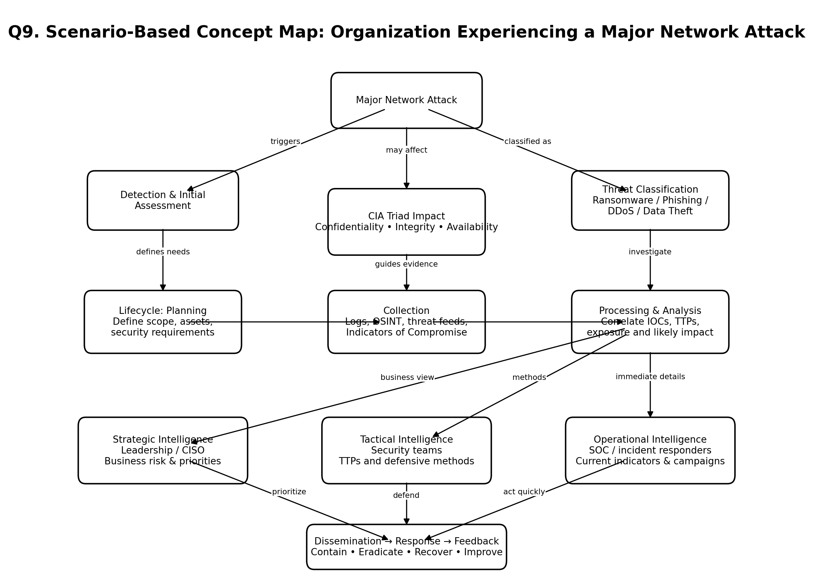
How the map works: Detection establishes what happened and which CIA goals are affected. Analysts collect logs, open-source intelligence, threat feeds, and indicators, then correlate them with known tactics, techniques, and procedures (TTPs). Strategic intelligence helps leaders prioritize business risk; tactical intelligence guides defensive methods; operational intelligence supports immediate investigation and response. Findings are disseminated, the attack is contained and recovered from, and feedback improves the next intelligence cycle.

Q10. Applications of Network Security and Threat Intelligence in the IT Industry
The IT industry combines network security controls with Threat Intelligence to protect information, systems, and services. The concept map shows how security fundamentals and CIA objectives connect to threats, intelligence types, the intelligence lifecycle, and practical applications.
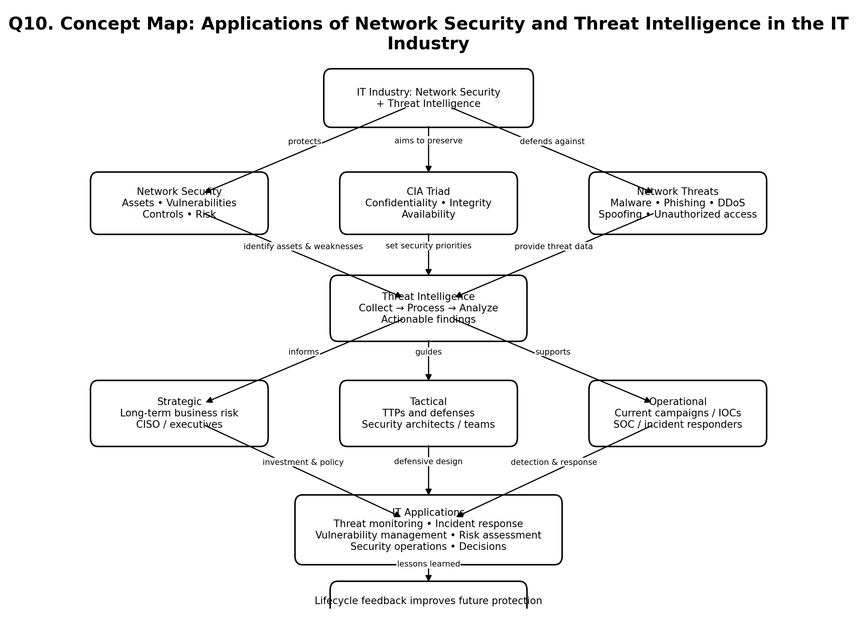
Application links: threat monitoring uses indicators and logs to identify suspicious activity; incident response uses operational intelligence to act quickly; vulnerability management uses threat and weakness information to prioritize fixes; risk assessment and organizational decision-making use strategic intelligence; and tactical intelligence helps teams improve security architecture, detection rules, and defensive procedures. Feedback from incidents and monitoring updates future collection and analysis.

